A MINI-PROJECT REPORT

ON

# “Movies Hub”

BY

## Khushi Gedam

## Kamran Dhopaunkar

## Advait Jadhav

Under the guidance of

##### Internal Guide Prof. Bhushan Patil



Juhu-Versova Link Road Versova, Andheri(W), Mumbai-53 University of Mumbai

APRIL- 2025



Juhu-Versova Link Road Versova, Andheri(W), Mumbai-53

### C E R T I F I C A T E

Department of Computer Engineering

This is to certify that

1. Khushi Gedam
2. Kamran Dhopaunkar
3. Advait Jadhav

Have satisfactorily completed this project entitled

##### “Movies Hub”

Towards the partial fulfilment of the

**THIRD YEAR BACHELOR OF ENGINEERING IN**

**(COMPUTER ENGINEERING)**

**as laid by University of Mumbai**.

**Prof. Bhushan Patil Bhushan Patil**

**Guide H.O.D.**

**Dr. Sanjay Bokade**

**Principal**

#### Project Report Approval for T. E.

This project report entitled **“Movies Hub*”*** by ***Khushi Gedam, Kamran Dhopaunkar, Advait Jadhav*** is approved for the degree of ***Third-Year Bachelor of Computer Engineering***.

##### Examiners:

1

2.

Date:

Place:

#### Declaration

We wish to state that the work embodied in this project titled **“Movies Hub”** forms our own contribution to the work carried out under the guidance of “**Prof. Bhushan Patil**” at the Rajiv Gandhi Institute of Technology.

I declare that this written submission represents my ideas in my own words and where others' ideas or words have been included, I have adequately cited and referenced the original sources. I also declare that I have adhered to all principles of academic honesty and integrity and have not misrepresented or fabricated or falsified any idea/data/fact/source in my submission. I understand that any violation of the above will be cause for disciplinary action by the Institute and can also evoke penal action from the sources which have thus not been properly cited or from whom proper permission has not been taken when needed.

|  |  |  |
| --- | --- | --- |
| **(Students Signatures)** |  | |
| Khushi Gedam | (A-666) |  |
| Kamran Dhopaunkar | (A-661) |  |
| Advait Jadhav | (A-664) |  |

## Abstract

MoviesHuB is a modern web-based streaming platform that provides users with seamless access to an extensive library of movies and TV shows sourced from various OTT (Over-The-Top) services, including Netflix, Amazon Prime, and more. Designed for an uninterrupted, ad-free viewing experience, MoviesHuB leverages a robust cloud infrastructure to ensure scalability, security, and performance.

The platform is built using React for an intuitive front-end experience, while Firebase powers user authentication, database management, and real-time updates. The backend services are implemented with Node.js, offering efficient API handling and content delivery. To enhance accessibility and performance, AWS S3 is utilized for content hosting and deployment, ensuring global availability and high uptime.

Security is a core focus of MoviesHuB, integrating AWS security protocols to safeguard user data and platform integrity. Key security implementations include:

1. AWS IAM (Identity and Access Management): Ensuring secure access control through role-based permissions and least privilege policies to mitigate unauthorized access.
2. AWS Shield Standard: Providing DDoS protection to defend against potential cyber threats and ensure platform reliability.
3. AWS CloudTrail & Security Hub: Enabling real-time monitoring of user activities, API interactions, and security insights for proactive threat detection and compliance tracking.

By utilizing a cloud-first architecture, MoviesHuB delivers a highly scalable, secure, and cost-effective entertainment hub, ensuring users can enjoy the latest releases without disruptions. This report delves into the platform architecture, feature set, implementation strategies, and security best practices, showcasing how cloud-based technologies enhance its reliability and user experience.

## Contents

|  |  |  |
| --- | --- | --- |
| 1 | **Introduction**   * 1. Introduction Description...……………………………………….   2. Organization of Report. ………………………………………….   3. Problem Statement……………………………………………….   4. Objectives………………………………………………………..   5. Scope…………………………………………………………….. | 1  1  2  2  2 |
| 2 | **Proposed System**   * 1. Proposed System………………………………………………..      1. Proposed Model……………………………………………      2. System Architecture……………………………………….   2. Details of Hardware & Software………………………………...      1. Software Requirement.…………………………………….      2. Hardware Requirement……………………………………...   3. Design Details……………………………………………………..      1. Activity Diagram………………...………………………….   4. Methodology/Procedures (Your methodology to solve problem).. | 3  3  4  5  6  7 |
| 4 | **Results**  4.1.1 Landing and Signup page…………………………………………  4.1.2 Home page………………………………………………………..  4.1.3 Video Stream page………………,,,……………………………...  4.1.4 Profile page……….………………………………………………  4.1.5 Navbar page………………………………………………………  4.1.6 Upload Content page……………………………………………..  4.1.7 Database Structure...……………………………………………...  4.1.8 Aws S3 Bucket……………………………………………………  4.1.9 Aws Cloud Trail………………………………………………….. | 8  9  9  10  11  11  12  14  14 |
| 5 | **Future Work and Conclusion**  5.1 Future Scope……………………………………………………….  5.2 Conclusion…………………………………………………………. | 15  15 |

### CHAPTER 1

##### Introduction Description

### ****1.1**** Introduction

This project introduces **MoviesHuB**, a cloud-powered streaming platform designed to provide users with seamless access to a vast collection of movies and TV shows from multiple OTT (Over-The-Top) services such as **Netflix, Amazon Prime, and more**. With an emphasis on a smooth, **ad-free viewing experience**, MoviesHuB integrates advanced cloud services to ensure high availability, security, and performance.

At its core, MoviesHuB leverages **cloud-native technologies** to deliver an efficient and scalable streaming solution. The platform is built using **ReactJS** for a dynamic and responsive front-end, while **Firebase** serves as the backend, handling authentication, real-time updates, and database management. To ensure a **highly reliable and cost-effective content delivery system**, MoviesHuB utilizes **AWS S3** for hosting and deployment, allowing seamless access to media content from anywhere.

Security is a **critical** aspect of MoviesHuB, with multiple AWS security protocols in place:

1. **AWS IAM (Identity and Access Management):** Ensures secure access control through role-based policies, adhering to the principle of least privilege.
2. **AWS Shield Standard:** Provides DDoS protection, safeguarding the platform against malicious attacks.
3. **AWS CloudTrail & Security Hub:** Monitors user activities and API calls, ensuring security compliance and proactive threat detection.

MoviesHuB also integrates **real-time content updates, personalized recommendations, and dynamic UI components** to enhance the user experience. By leveraging **cloud technologies**, the platform ensures **scalability, security, and uninterrupted streaming**, making it a comprehensive and **future-ready** entertainment hub.

### 1.2 Organization of Report

Each chapter in this report outlines a key component of MoviesHuB’s development, from conceptualization to implementation and security considerations:

* **Ch.1 Introduction:** This section introduces the **MoviesHuB** project, highlighting its core objectives, cloud infrastructure, and security features.
* **Ch.2 Literature Review:** This section discusses existing **streaming platforms** and related cloud-based solutions, comparing methodologies and technologies used in the industry.
* **Ch.3 Proposed System:** This section details the **MoviesHuB architecture, implementation strategy, and cloud integration**, including Firebase, AWS S3, and security mechanisms.
* **Ch.4 Results:** This section presents the **performance analysis, scalability insights, and security assessments** of MoviesHuB, demonstrating its effectiveness as a modern cloud-powered streaming platform.

This structured approach ensures a **comprehensive understanding** of MoviesHuB’s development and its impact as a **secure, scalable, and user-centric** streaming service.

### ****1.3 Problem Statement****

1. To develop a **cloud-powered** streaming platform that allows users to access a vast collection of movies and TV shows seamlessly, without ads or buffering issues.
2. Existing challenges in the streaming industry:
   * **Scalability Issues:** Traditional streaming platforms often face server overloads and limited scalability, leading to poor performance during high-traffic periods.
   * **Security Concerns:** Streaming services are vulnerable to cyber threats, including data breaches and unauthorized access.
   * **Content Availability & Delivery:** Efficient content hosting and delivery require a cloud-based infrastructure to ensure global accessibility with minimal latency.

### ****1.4 Objectives****

1. **Ensure Seamless Streaming Performance:** Utilize **AWS S3 for content hosting** and **Firebase for backend management**, enabling smooth and scalable video streaming.
2. **Enhance Security & Data Protection:** Implement **AWS IAM, AWS Shield, and AWS CloudTrail** to ensure user data security, protect against DDoS attacks, and monitor activity for compliance.
3. **Deliver a Dynamic & Personalized User Experience:**
   * Integrate **real-time recommendations** powered by Firebase and cloud-based AI models.
   * Provide **interactive UI components** using React to improve user engagement.
4. **Enable High Availability & Scalability:**
   * Deploy the platform using **AWS cloud infrastructure** to ensure high uptime.
   * Utilize **auto-scaling and serverless technologies** to manage varying traffic loads efficiently.
5. **Optimize Content Delivery:** Use **CDN (Content Delivery Network) and AWS S3** to minimize latency and enhance video playback performance across different regions.

### ****1.5 Scope****

#### ****1. Front-End Development (ReactJS)****

* **Create a modern, responsive, and intuitive UI** for a seamless viewing experience.
* **Implement real-time updates** for personalized recommendations and recently added content.
* **Enhance accessibility** with features such as subtitles, multi-language support, and adaptive video quality selection.

#### ****2. Back-End Development (Firebase & AWS Services)****

* **Establish a secure, scalable cloud-based backend** using Firebase for real-time database management and user authentication.
* **Implement efficient content hosting & delivery** via **AWS S3 and a global CDN to** ensure fast, uninterrupted streaming.
* **Integrate advanced security measures** using **AWS IAM for access control, AWS Shield for DDoS protection, and AWS CloudTrail for activity monitoring.**

By leveraging **cloud computing, serverless technologies, and AWS security protocols,** MoviesHuB is designed to **offer a scalable, secure, and high-performance streaming experience** while ensuring global accessibility and seamless content delivery.

**CHAPTER 3**

# 3.1Proposed System

##### Proposed Model

Fig. 3.1.2 Proposed Model

The proposed MoviesHuB system is a cloud-based movie streaming platform designed to provide seamless content access, personalized recommendations, and secure user management. Developed using React.js for the front-end and Node.js for the backend, it ensures a smooth and interactive user experience. Firebase RealtimeDatabase efficiently manages user data and content metadata, while FirebaseAuthentication provides secure login options, including email/password and Google OAuth. Users can browse movies, create watchlists, and receive real-time notifications about new releases and trending content.

By leveraging machine learning, MoviesHuB offers personalized recommendations based on user preferences and watch history, enhancing content discovery. The system is hosted on AWS S3, ensuring high availability and optimized streaming, while Firebase Hostin**g** supports reliable front-end deployment. Security is reinforced through AWS IAM, AWS Shield, and CloudTrail, protecting user data and preventing cyber threats. With scalability, efficiency, and security at its core, MoviesHuB delivers a modern, feature-rich, and **engaging** streaming experience.

##### System Architecture

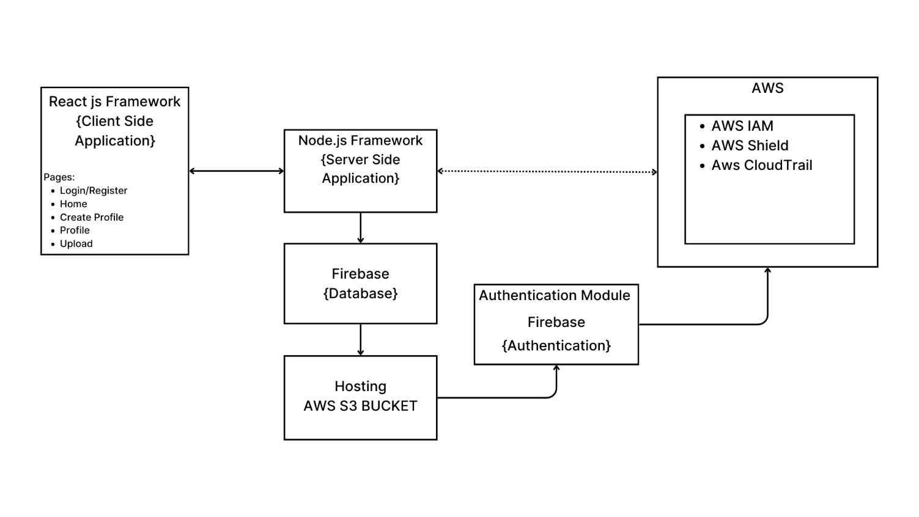

Fig. 3.1.3 System Architecture

The system architecture of **MoviesHuB** integrates **React.js** for the front-end**,** a **Node.js backend**, and **Firebase** for authentication and database management. The front-end consists of pages such as **login/register, home, movie catalog, watchlist, and user profile**. Movies and TV shows are hosted on **AWS S3**, ensuring high availability and seamless content delivery. The backend processes user requests, manages content metadata, and interacts with Firebase for user data storage. A **Content Delivery Network (CDN)** optimizes video streaming, reducing latency and improving playback quality. Additionally, **AWS security services** (IAM, Shield, and CloudTrail) safeguard the platform against cyber threats, ensuring a secure and scalable cloud-powered streaming experience.

##### Details of hardware and software

* + 1. **Software requirements:**
* **Frontend:**
* **React.js** – For building a dynamic and responsive user interface.
* **Redux (optional)** – For state management and handling user interactions efficiently.
* **Backend:**
* **Node.js (Express.js)** – For handling server-side logic, API requests, and data processing.
* **Firebase Functions** – For executing backend logic in a serverless environment.
* **Database & Authentication:**
* **Firebase Realtime Database** – For storing user profiles, watch history, and content metadata.
* **Firebase Authentication** – For secure user login via Email/Password and Google OAuth.
* **Cloud Services & Hosting:**
* **AWS S3 –** For content hosting and streaming.
* **AWS CloudFront (CDN)** – For optimized content delivery with minimal latency.
* **Firebase Hosting** – For deploying the front-end application.
* **Security & Monitoring:**
* **AWS IAM** – For managing secure user access and roles.
* **AWS Shield** – For protecting against DDoS attacks.
* **AWS CloudTrail & Security Hub** – For tracking API calls and monitoring security insights.
* **Development Tools:**
* **VS Code** – For coding and debugging.
* **Git & GitHub** – For version control and collaborative development.
* **Postman** – For testing APIs.

##### Hardware requirements

* **Server Requirements (For Development & Deployment):**
* **Processor:** Intel Core i5 or higher (or equivalent).
* **RAM:** Minimum 16GB for smooth development and testing.
* **Storage:** 256GB SSD or more for efficient data management.
* **Network:** Stable high-speed internet connection for real-time data access and cloud synchronization.

##### Design Detail

Fig. 3.1 Activity Diagram

##### Methodology/Procedure

* **Content Collection & Processing:**
  + Movies and TV shows are sourced from licensed databases and stored in FirebaseRealtime Database with metadata like title, genre, and ratings. Video files are optimized and compressed for smooth streaming.
* **User Authentication & Management:**
  + Firebase Authentication handles secure login via email/password and Google OAuth, while user preferences and watch history are stored for personalization.
* **Backend Development & API Integration:**
  + Node.js powers the backend, managing user requests and streaming services. RESTful APIs ensure seamless communication between the frontend and backend.
* **Streaming & Content Delivery:**
  + Movies are hosted on AWS S3 and delivered via CDN, ensuring high availability and minimal buffering.
* **Recommendation System:**
  + AI-driven algorithms analyze watch history and engagement to provide personalized content recommendations and highlight trending movies.
* **Security & Optimization:**
  + **AWS IAM** ensures secure role-based access.
  + **AWS Shield** protects against DDoS attacks.
  + **AWS CloudTrail & Security Hub** monitor security and API usage.
* **Frontend Development & Deployment:**
  + The React.js frontend ensures a smooth, interactive experience, while hosting on AWS S3 and Firebase guarantees scalability and reliability for global users.

This methodology ensures MoviesHuB is secure, scalable, and optimized for seamless movie streaming.

**CHAPTER 4**

**4.1 Result**

**4.1.1. Login and Signup Pages**



Figure 1: Login Page UI



Figure 2: Signup Page UI

**4.1.2. Home Page** 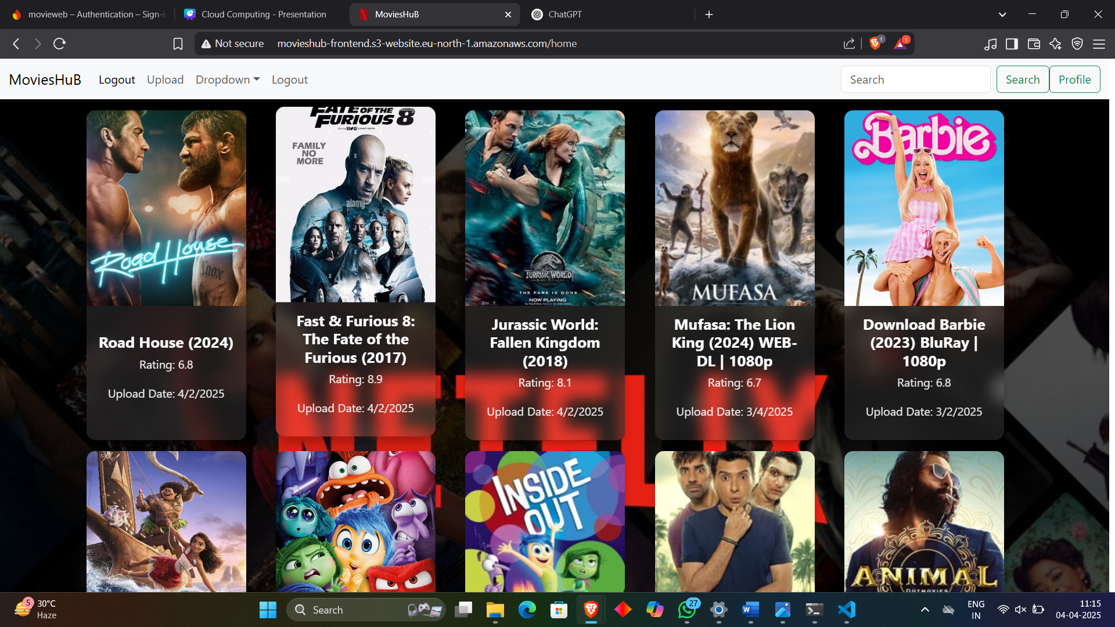

Figure 3: Home Page UI

**4.1.3. Video stream Page**



Figure 4: Video Stream

**4.1.4. Profile Pages **

Figure 4: Create Profile Page UI



Figure 5: Profile Page UI

**4.1.5. Navigation Bar**

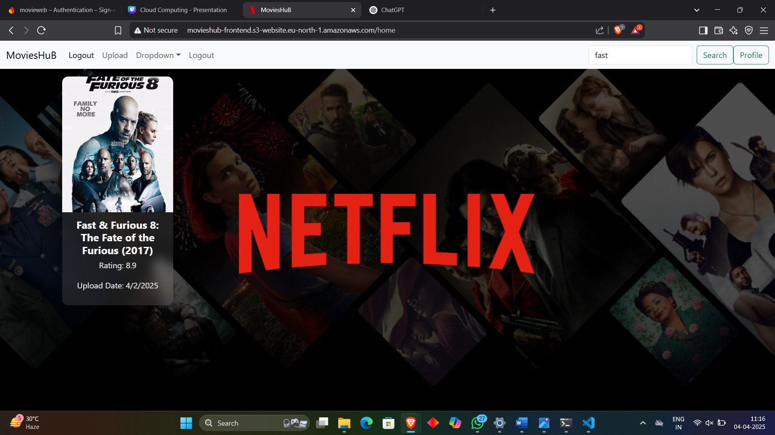

Figure 6: Navigation Bar with search engine

**4.1.6 Upload content**



Figure 7: upload content page

**4.1.7 Database Structure**

**  **

Figure 8: Firebase Database Structure

**4.1.8 S3 bucket for deployment**

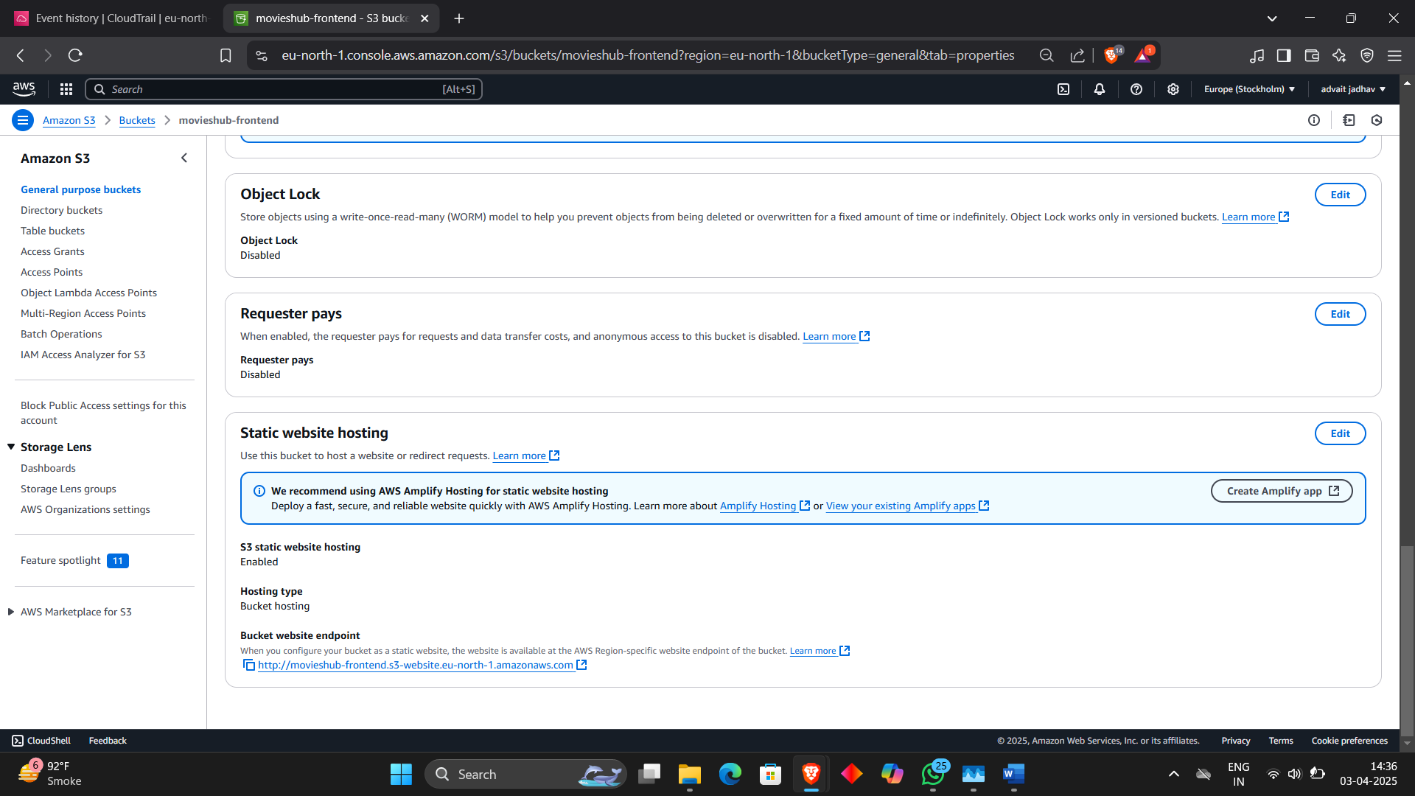

**4.1.9** AWS **CloudTrail**

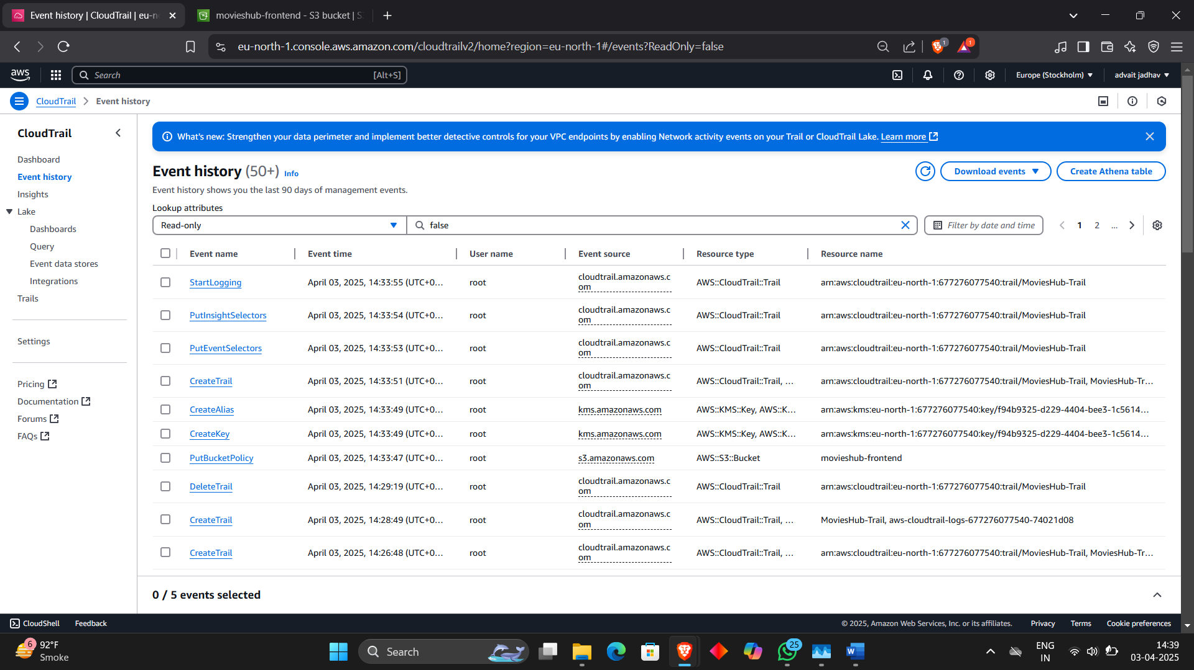

**CHAPTER 5**

**5.1 Future Scope:**

The future scope of the MoviesHuB project includes several enhancements to improve user experience and platform scalability. Implementing AI-driven content recommendations using deep learning models will provide more personalized suggestions. Multi-language support and subtitles will enhance accessibility for a global audience. The integration of live streaming and pay-per-view events can expand the platform’s reach beyond on-demand content. A mobile application for Android and iOS will provide a seamless streaming experience across devices. Additionally, blockchain-based content protection could enhance security and prevent piracy. Expanding serverless architecture on AWS for better scalability and reducing infrastructure costs will further optimize the platform. These advancements will make MoviesHuB a leading, cloud-powered streaming service.

**5.2 Conclusion:**

The MoviesHuB platform successfully delivers a cloud-based, ad-free streaming experience, leveraging React.js, Firebase, and AWS for seamless content delivery and security. With AWS S3 for storage, Firebase Authentication for user management, and AI-driven recommendations, the platform offers a modern, scalable, and personalized entertainment solution. The secure architecture with AWS IAM, Shield, and CloudTrail ensures data protection and platform stability. This project demonstrates the potential of integrating cloud computing, AI, and scalable architectures to create a robust and user-friendly OTT streaming service, offering an immersive and uninterrupted entertainment experience.

#### Acknowledgement

We wish to express our sincere gratitude to **Dr. Sanjay U. Bokade, Principal** and **Prof. Bhushan PatilS. P. Khachane , H.O.D.** of Department Computer Engineering of Rajiv Gandhi Institute of Technology for providing us an opportunity to do our project work on **“(Movie Hub)”**.

This project bears on imprint of many peoples. We sincerely thank our project guide Dr/Prof. **(Prof. Bhushan Patil)** for her guidance and encouragement in carrying out this synopsis work.

Finally, we would like to thank our colleagues and friends who helped us in completing project work successfully.

* 1. Khushi Gedam
  2. Kamran Dhopaunkar
  3. Advait Jadhav